**[TEMPLATE] CS First Workshop Guide**

**NOTE FOR CONTRIBUTORS: When using this document for your workshop, make sure to make a copy before you replace all links and titles to align with your repository!**

**DELETE ALL RED TEXT BEFORE POSTING YOUR COPY - MAKE SURE TO INCLUDE THIS TEMPLATE IN THE SAME FOLDER AS YOUR EDITED PDF SO IT CAN BE USED IN FUTURE PROJECTS**

**Upload your edited copy as both a PDF and a Word Document, but keep the template in Word Document format**

## **Accessing the Workshop File through CS First**

### **Step 1**: Download the [.sb3 file](https://github.com/jvalram/planimals/blob/main/Code/PlanimalsWorkshop.sb3) in the ‘code’ folder of this workshop

// CONTRIBUTORS: Highlight or right click the underlined text, click Edit Link, and replace the link with one that leads to the web page containing your Scratch .sb3 file

The file can be found in the code folder of this repository or accessed directly through the highlighted text above.

Click on **'view raw'** to download (*make sure to download a copy to a flash drive if your Classroom doesn’t have access to Google Drive/OneDrive!*)

### **Step 2**: Uploading the file to CS First

* Open CS First, click the **plus** sign, and select **New Project**.

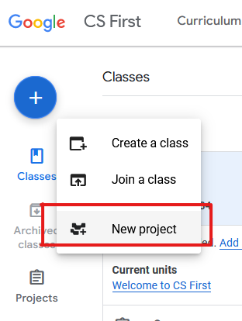

* Click File

NOTE: The file name used in the photo is just an example, you can rename the file to match the workshop or leave it as is.



* Click 'Load from your computer' and select the sb3 file that was downloaded earlier. We recommend saving it to the downloads folder so it can be accessed more easily.

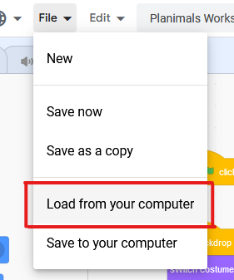

TEACHERS: Feel free to work through the workshop on your own to familiarize yourself with the lesson!

## **Sharing the Workshop with Your Classroom**

At the time of this document's creation, there is unfortunately no way to share custom .sb3 files or CS First Playground Projects to a Google Classroom through CS First.

Here are a few alternative methods suggested by CS First Customer Support for sharing the workshop with your class.

### **Option 1:** Sharing the file via Google Drive

If you have a Google Drive/OneDrive account that is accessible to your classroom, you can take the downloaded [.sb3 file](https://github.com/jvalram/planimals/blob/main/Code/PlanimalsWorkshop.sb3) and upload it somewhere that your students can easily access it.

// CONTRIBUTORS: Remember to update this link!

Once they’ve downloaded the file, they can follow the same steps taken in Step 2 of the Accessing the Workshop File segment of this document.

### **Option 2:** Sharing the File via Flash Drive

**The** [**.sb3 file**](https://github.com/jvalram/planimals/blob/main/Code/PlanimalsWorkshop.sb3) **will have to be downloaded onto a flash drive and uploaded to every individual computer.**

// CONTRIBUTORS: Remember to update this link!

Upload the file to each student's individual computer using the flash drive.

Open up Documents, Go to the Downloads folder, and Drag and drop the file from the flash drive folder into your students downloads folder

Once the file is transferred over to the Student computer, follow the same steps taken in Step 2: Accessing the Workshop File

### **Option 3**: Contact IT/Administration

If you don’t have permission to use Google Drive/OneDrive to share the file or don’t have access to a flash drive, you can contact your school’s administration or IT office to see if the .sb3 file can be uploaded remotely to your classroom's computers.